|  |  |
| --- | --- |
| Name: | Prerna Sunil Jadhav |
| Sap  Id: | 60004220127 |
| Class: | T. Y. B.Tech (Computer Engineering) |
| Course: | Processor Organization and Architecture (POA) |
| Course Code: | DJ19CEL502 |
| Experiment  No.: | 05 |

**AIM:** Assembly program for 16-bit addition/subtraction using direct, Immediate & register addressing mode.

ADDITION:

**CODE**:

org 1000h

mov ax,[1000h]

mov bx,[1002h]

add ax,bx

mov ax,1234h

mov bx,0005h

add ax,bx

mov ax,1234h

mov bx,1000h

add ax,[bx]

**OUTPUT**:

ADDITION-DIRECT:

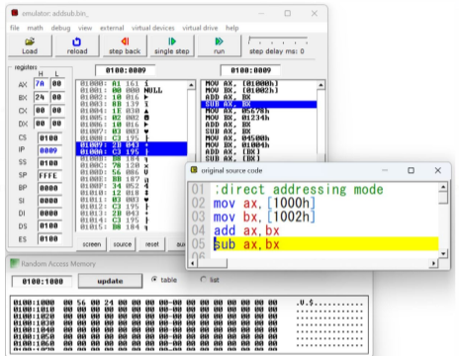

ADDITION-IMMEDIATE:

ADDITION-REGISTER INDIRECT

SUBTRACTION:

**CODE**:

org 1000h

mov ax,[1000h]

mov bx,[1002h]

sub ax,bx

mov ax,1234h

mov bx,0005h

sub ax,bx

mov ax,1234h

mov bx,1000h

sub ax,[bx]

**OUTPUT:**

SUBTRACTION-DIRECT

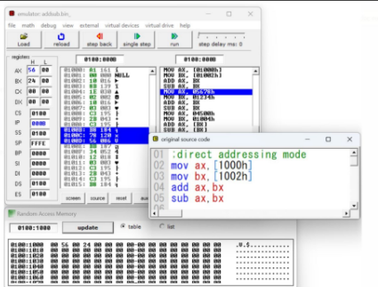

SUBTRACTION-IMMEDIATE:

SUBTRACTION-REGISTER INDIRECT:

